––––1. SDLC OVERVIEW–

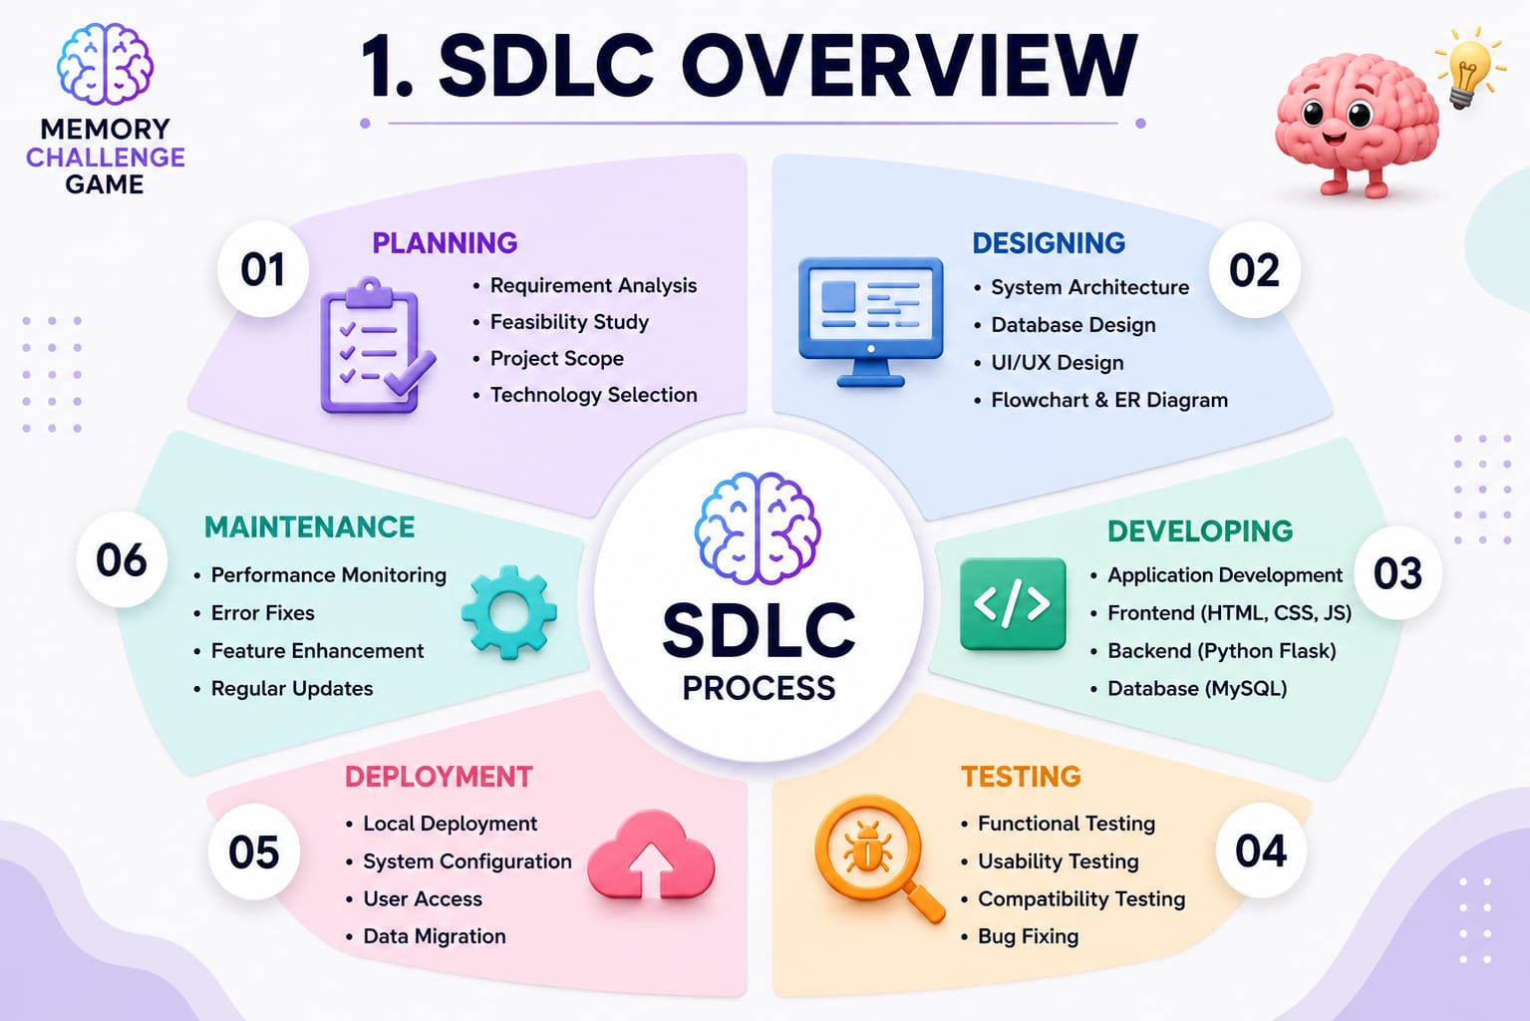

2. REQUIREMENT GATHERING AND ANALYSIS

  - ORGANIZATION DETAILS:

1. Name of the Organization: -
Innovate Tech Solutions Pvt. Ltd.

2. Brief detail of the organization: -
TechNova Solutions is an IT training and software development organization that provides practical knowledge in programming, web development, and database management. It guides students in developing real-time projects and improving their technical skills.

  - MEETINGS:

I. Meeting with Project Manager

1. Name of Project Manager:
- Mr. Rahul Sharma
2. Project Manager’s Requirement
The project should be user-friendly.
- The project should be user-friendly.
- It should improve users' memory and concentration.
- The project should be tested properly and completed on time.

II. Meeting with user

- Name of the user.
-Ms. Riya Patel

- User requirement in her words.
A simple and interactive memory game is required to improve users' memory, concentration, and observation skills through different game levels.
2.3 Data which will be the input into the system….
- User Name
- Login Details
- Game Level Selection
- User Answers
2.4 Data which will be the output from the system….
- Memory Sequence
- Game Result
- Score
- Accuracy/Performance
2.5 Type of project….
- Web-Based Application
2.6 Method for collecting data.
- Interviews.
- User Feedback
- Internet Research

3. SYSTEM REQUIREMENT SPECIFICATIONS

3.1 Introduction:
The Memory Challenge Game is a web-based application developed to improve users' memory, concentration, and observation skills through interactive game levels. The system provides a simple and engaging interface where users can register, log in, play memory games, and view their results

3.1.1 Purpose:
The purpose of the Memory Challenge Game is to help users enhance their memory skills by remembering and recalling numbers, words, or patterns within a limited time. It also provides an enjoyable learning experience through different difficulty levels.
.

    - Intended Audience and Reading Suggestions:
This document is intended for project guides, developers, testers, and end users. It provides complete information about the design, development, and functionality of the Memory Challenge Game.
    - Product Scope:

The Memory Challenge Game allows users to register, log in, play memory-based challenges, and view their scores. The system aims to improve memory and concentration while providing an interactive and user-friendly gaming experience.

  - Overall Description:

    - Product Function:

- Admin Module :
- User Registration
- User Login
- Dashboard
- Start Memory Challenge
- Display Random Numbers/Words
- Timer for memorization
- Submit Answer
- View Score / Result
- Logout

- User Module :
- Register
- Login
- Play Memory Challenge
- Logout

    - User classes and characteristics:

- User Classes :
- Administrator
- User

- User Characteristics :
- Administrator:
- Manages user accounts.
- Monitors game data and scores.
- Updates game levels when required.
- User :
- Registers and logs into the system.
- Plays the memory challenge game.
- Selects difficulty level.
- Views score and game results.

    - Operating Environment:
The Memory Challenge Game is a web-based application that runs on computers or laptops with an internet connection. It is compatible with Windows operating systems and can be accessed through a web browser

    - Design and Implementation constraints:

- User-friendly graphical interface.
- Internet connection is required.
- User should have basic computer knowledge.
- 0The system is developed using Python Flask and MySQL.

    - Assumptions and dependencies:

- Users must register before playing the game.
- Internet connection is required.
- The database stores user details and scores..

3.3 External Interface Requirement:

3.3.1 User Interface:
The system provides a simple and user-friendly interface. Users can register, log in, start the memory game, submit answers, and view their scores easily
3.3.2 Software Interface:

- Operating System: Windows 10/11
- Frontend: HTML, CSS, JavaScript
- Backend: Python (Flask)
- Database: MySQL
- IDE: Visual Studio Code

  - System Features:

- User Registration
- User Login
- Play Memory Game
- View Score
- Logout

  - Other Nonfunctional Requirements:

3.5.1 Performance requirement:

- Overall System should be fast and error free.
- It should have built in error checking and correction facilities.
- The system should be able to handle large amount of data.

    - Security Requirement:
- The system should respond quickly.
- The game should run without errors.

    - Safety Requirement:

- User information should be protected.
- The system should prevent data loss

  - Feasibility Study

A feasibility study is conducted to determine whether the Memory Challenge Game can be developed and implemented successfully using the available resources and technologies.

3.6.1 Operational Feasibility: -

The system is easy to use and helps users improve their memory through an interactive game. It provides a simple interface and can be operated without difficulty.

3.6.2 Technical Feasibility: -

The project is developed using Python (Flask), HTML, CSS, JavaScript, and MySQL, which are suitable technologies for building a web-based application.

3.6.3 Economic Feasibility: -

The project is cost-effective because it uses open-source software and requires minimal hardware resources.

3.6.4 Schedule Feasibility: -

The project can be completed within the given academic timeline using the available resources.

- SYSTEM ANALYSIS AND MODELING

  - Use case Diagram:
1) Admin Side

Login

Manage
Users

Manage
Game

Manage Questions/

View
Result

ADMIN

2) User Side
Register/Login

View
Dashboard

Start Game

Play
Game

View Score

USER

  - Normalization & E-R Diagram:

- Normalization is the process of organizing data in a database into tables to reduce data redundancy and improve data integrity. In the Memory Challenge Game, normalization is used to separate user information from game score information.
- De Normalized Form:

id | username | email | password | score | result | level
1 | Parth | parth@gmail.com | 14787 | 80 | Passed | 1
2 | Arjun | arjun@gmail.com | 88888 | 70 | Passed | 2
3 | Paras | paras@gmail.com | 784562 | 50 | failed | 1

- Normalized Form:

- 1st Normal Form:

id * (AI) | name | email | mobile | password
1 | Parth D Bheda | parthjam09@gmail.com | 72290 72200 | parth@123
2 | Bhavin D Badiyani | badiyani169@gmail.com | 97123 24710 | bhavin@123
- Table Name : users
Primary key: id (Auto increment)

- Table Name : game_scores
Primary Key: id (Auto Increment)
Forigen Key : user_id
id * (AI) | User_id(fk) | Score | level | Result | Played_at
1 | 1 | 80 | 1 | Passed | 2026-09-17
2 | 1 | 70 | 2 | Passed | 2026-09-18

- 2nd Normal Form:

- Table Name : users
Primary Key: id (Auto Increment)

User id | User name | email | password
1 | parth | parth@gmail.com | *12*3*
2 | arjun | arjun@gmail.com | 565424

- Table Name : game_scores
Primary Key: id
Foreign Key: user_id to user.id

id* (AI) | User_id(FK) | score | level | result | Played_at
1 | 1 | 80 | 1 | pass | 2026-2-9
2 | 1 | 70 | 2 | pass | 2026-7-12

- E-R Diagram

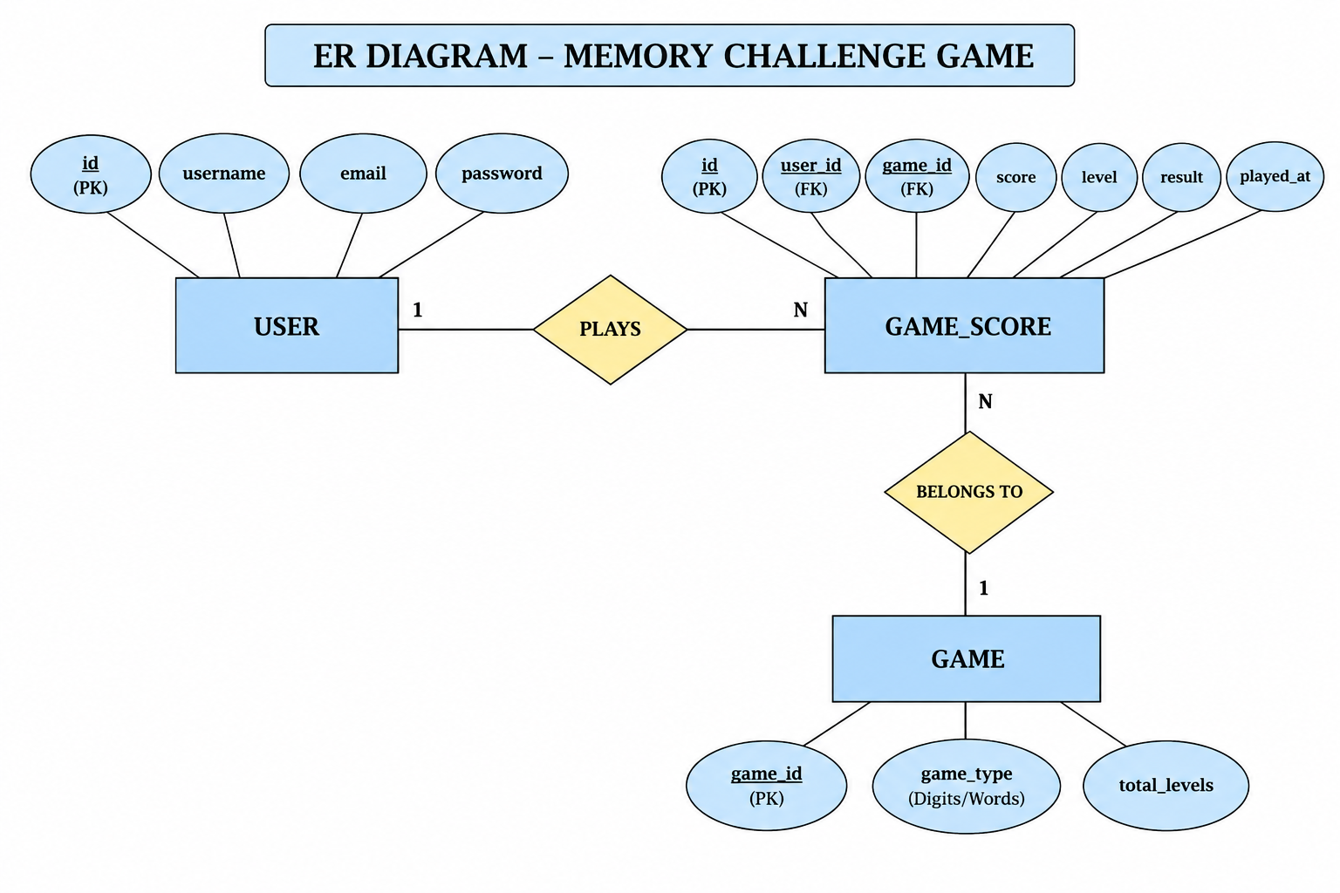

  - Data Dictionary

- tbl_user:–

SRNO. | COLUMN NAME | DATATYPE | NULL | LINKS TO | COMMENTS
1 | Id | Int(11) | NO |  | Primary Key, Auto Increment
2 | username | Varchar(50) | NO |  | username
3 | Email | Varchar(100) | NO |  | User Email
4 | password | Varchar(100) | NO |  | User Password

- tbl_game_scores
SRNO. | COLUMN NAME | DATATYPE | NULL | LINKS TO | COMMENTS
1 | Id | Int(11) | NO |  | Primary Key, Auto Increment
2 | user_id | Int(11) | NO | tbl_user → id | Foreign Key
3 | score | Int(11) | NO |  | Game Score
4 | Game Score | Int(11) | NO |  | Game Level
5 | result | Varchar(20) | YES |  | Won / Lost
6 | played_at | Timestamp | YES |  | Game Played Date & Time

3) tbl_digits_game
SRNO. | COLUMN NAME | DATATYPE | NULL | LINKS TO | COMMENTS
1 | level | Int(11) | NO | tbl_game_scores → level | Primary Key, Auto Increment
2 | digit_sequence | Varchar(50) | NO |  | Random Digits
3 | user_answer | Varchar(50) |  |  | User Entered Answer
4 | score | Int(11) | NO | tbl_game_scores → score | Score Obtained
5 | result | Varchar(20) |  | tbl_game_scores → result | Won / Lost
  YES

4) tbl_words_game
SRNO. | COLUMN NAME | DATATYPE | NULL | LINKS TO | COMMENTS
1 | word_sequence |  | NO |  | Random Words
  Varchar(100)
2 | user_answer | Varchar(100) | NO | tbl_user email | User Entered Answer
3 | score | int(11) | NO | tbl_game_scores → score | Score Obtained
4 | result | Varchar(20) | YES |  | Won / Lost
  tbl_game_scores → result
  W

4.3Functional and behavior modeling

    - Context Diagram(0-level Diagram)

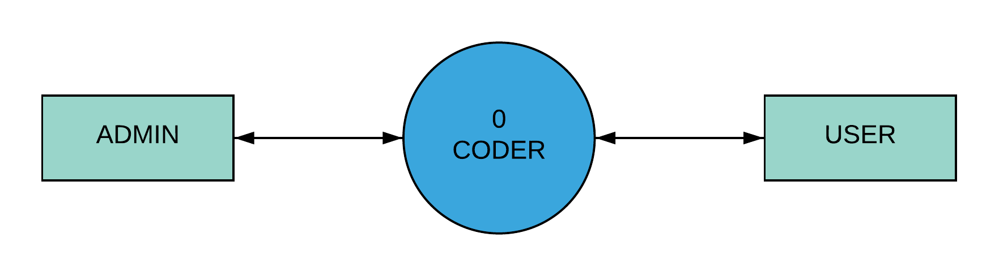
MEMORY CHALLENGE GAME

4.3.2 First Level Diagram (1-level Diagram)

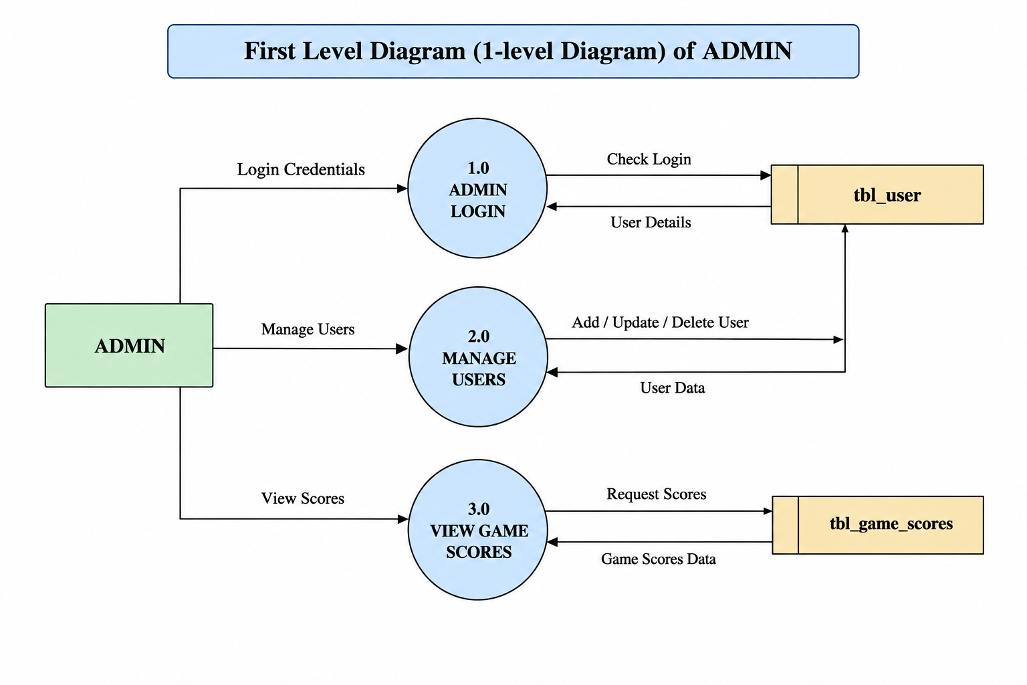
- ADMIN

- USER
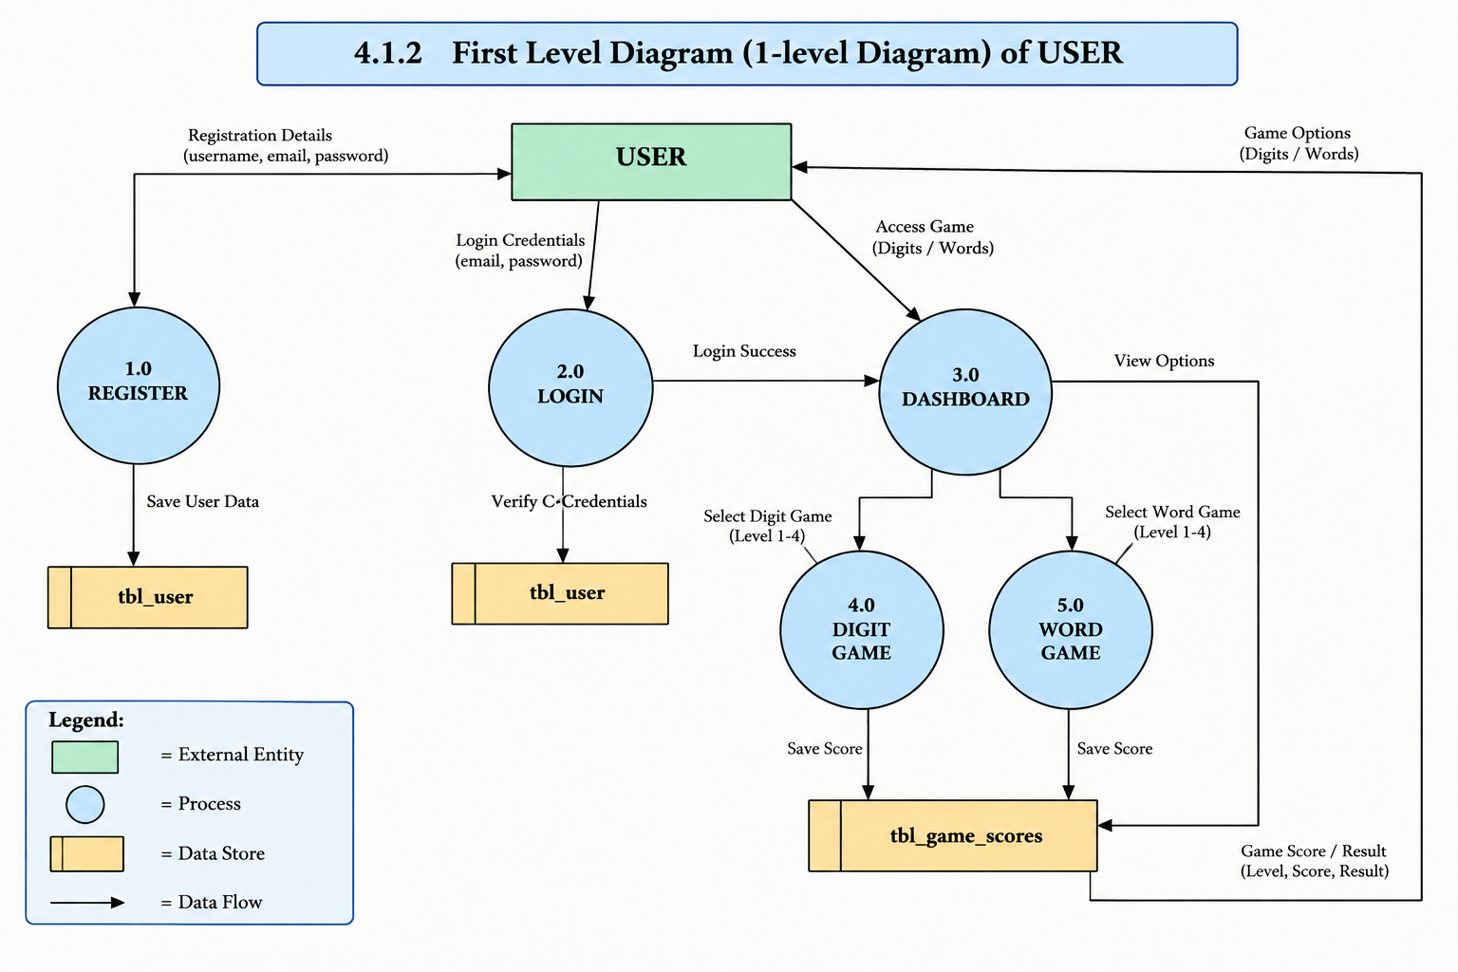

4.4 Gantt Chart

- Expected Time.

- Actual Time.

No. | Task | November | December | January | February
1 | Requirement Gathering And SRS
2 | System Analysis
3 | System Design
4 | System Development
5 | System Integration
6 | System Testing
7 | Documentation and Deployment

- TEST CASE
TEST CASE No. 1 — Login Module
TEST TITLE: Login Module Test
DESCRIPTION: Login functionality will be tested.
PRECONDITION: User must be registered.

STEP | TEST STEP | TEST DATA | EXPECTED RESULT | ACTUAL RESULT | STATUS
1 | Open Login | Login Page | Login page visible | Same as expected | PASS
2 | Enter Email | mahek@gmail.com | Email accepted | Same as expected | PASS
3 | Enter Password | mahek123 | Password accepted | Same as expected | PASS
4 | Click Login | Button Click | Dashboard opens | Same as expected | PASS

* Note :- Email is not accepted in above test case due to invalid format.

TEST CASE No. 2 — Registration Module
TEST TITLE: Registration Module Test
DESCRIPTION: Registration functionality will be tested.
PRECONDITION: Registration page must be working.

STEP | TEST STEP | TEST DATA | EXPECTED RESULT | ACTUAL RESULT | STATUS
1 | Open Registration | Register Page | Page visible | Same as expected | PASS
2 | Enter Details | Name, Email, Password | Details accepted | Same as expected | PASS
3 | Click Register | Button Click | Account created | Same as expected | PASS
4 | Open Login | Login Page | Login page opens | Same as expected | PASS

TEST CASE No. 3 — Dashboard Module
TEST TITLE: Dashboard Test
DESCRIPTION: Dashboard functionality will be tested.
PRECONDITION: User must be logged in.

STEP | TEST STEP | TEST DATA | EXPECTED RESULT | ACTUAL RESULT | STATUS
1 | Open Dashboard | Dashboard | Dashboard visible | Same as expected | PASS
2 | Check User | User Details | Details displayed | Same as expected | PASS
3 | Check Games | Digits, Words | Games visible | Same as expected | PASS
4 | Select Game | Game Click | Game opens | Same as expected | PASS

TEST CASE No. 4 — Digit Game
TEST TITLE: Digit Game Test
DESCRIPTION: Digit memory and scoring will be tested.
PRECONDITION: User must be logged in.

STEP No. | TEST STEP | TEST DATA | EXPECTED RESULT | ACTUAL RESULT | STATUS
1 | Open Digit Game | Digits | Game opens | Same as expected | PASS
2 | Show Digits | 2, 5, 6, 7 | Digits displayed | Same as expected | PASS
3 | Enter Answer | 2567 | Answer accepted | Same as expected | PASS
4 | Check Score | Correct Answer | Score displayed | Same as expected | PASS
5 | Next Level | Level 2–4 | New digits displayed | Same as expected | PASS

TEST CASE No. 5 — Word Game
TEST TITLE: Word Game Test
DESCRIPTION: Word memory and scoring will be tested.
PRECONDITION: User must be logged in

STEP No. | TEST STEP | TEST DATA | EXPECTED RESULT | ACTUAL RESULT | STATUS
1 | Open Digit Game | Digits | Game opens | Same as expected | PASS
2 | Show Digits | 2, 5, 6, 7 | Digits displayed | Same as expected | PASS
3 | Enter Answer | 2567 | Answer accepted | Same as expected | PASS
4 | Check Score | Correct Answer | Score displayed | Same as expected | PASS
5 | Next Level | Level 2–4 | New digits displayed | Same as expected | PASS

- SCREEN SHOTS

- User Side

  - This Activity Displays Registration Screen
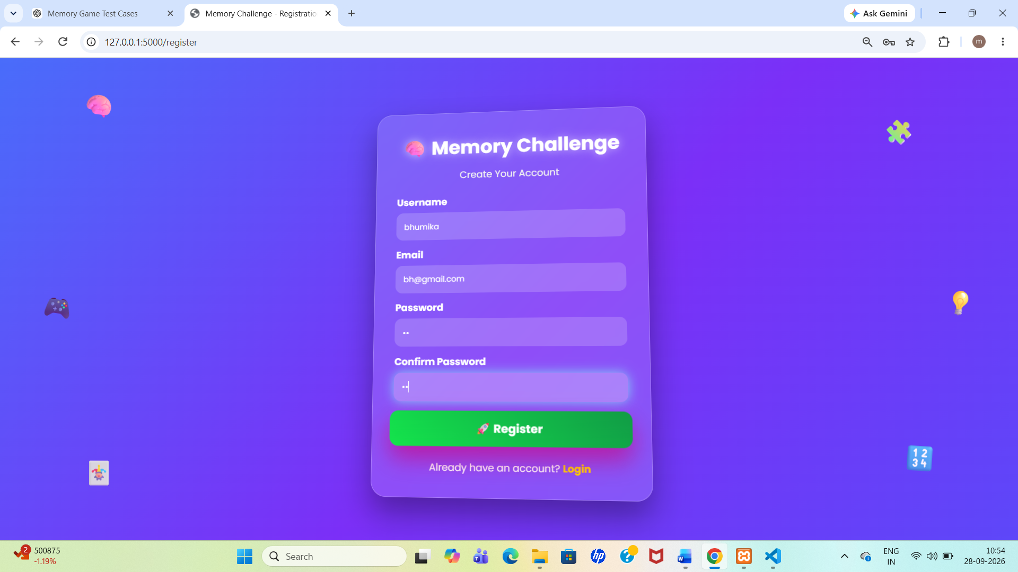

6.2 Login Activity
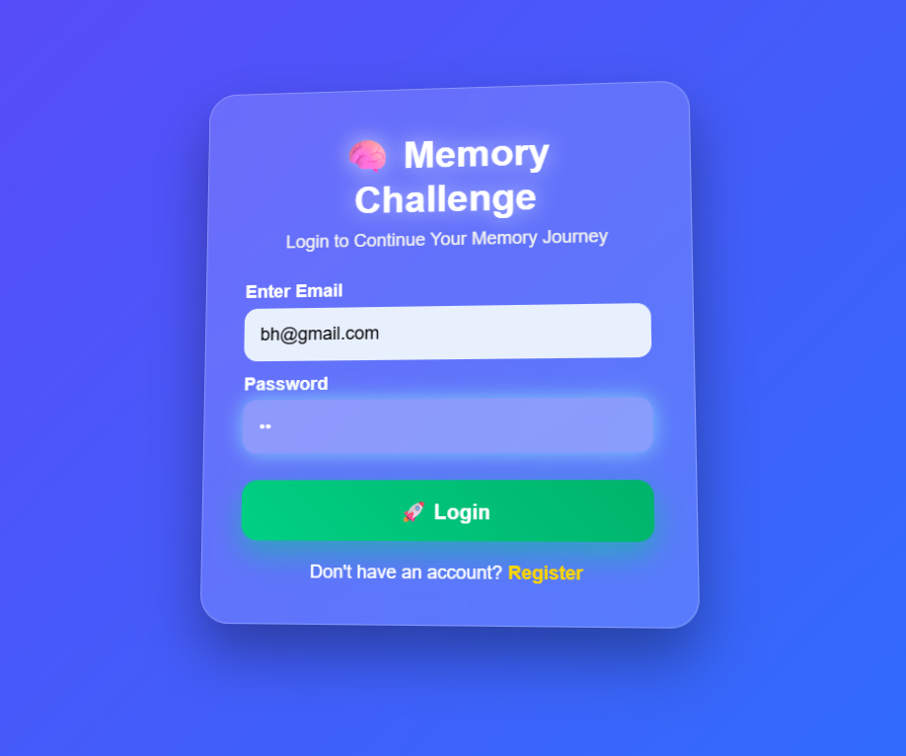

  - This Activity Displays Dashboard Screen
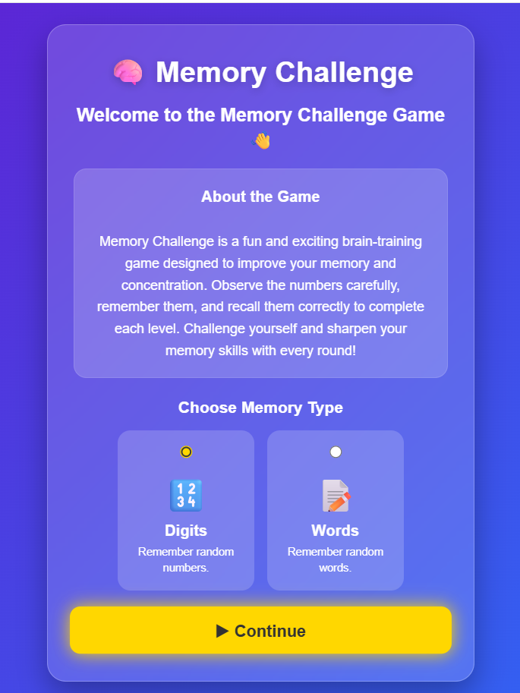

6.4 This Activity Displays Digits Game

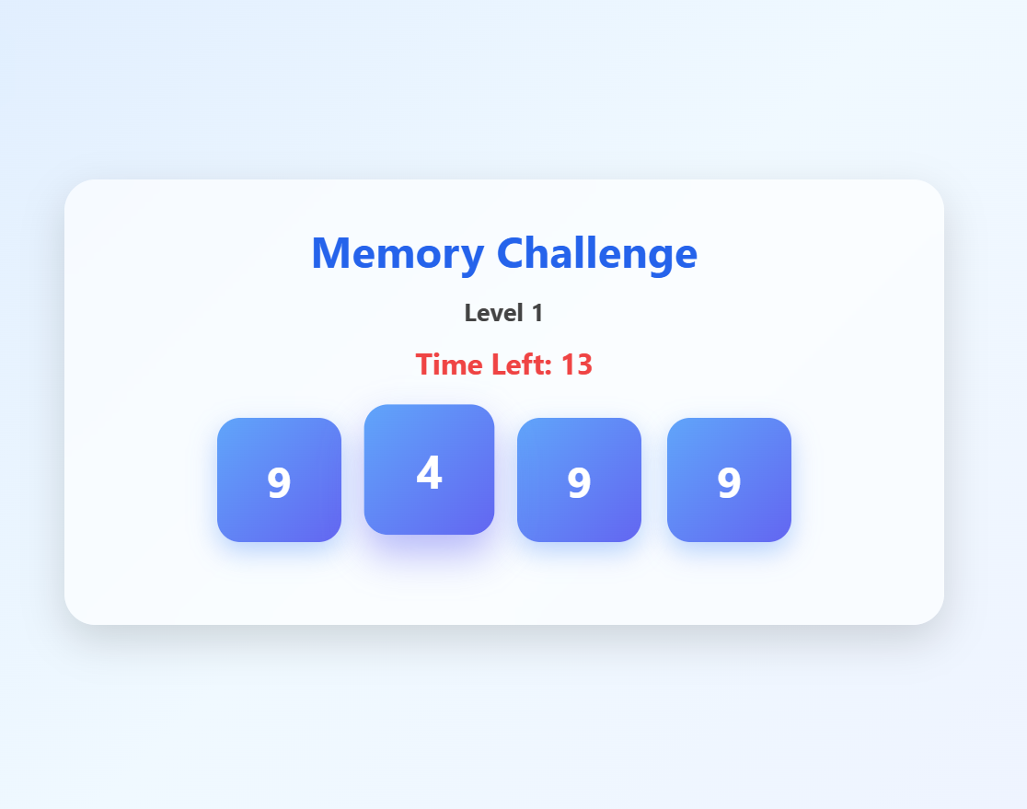

This contains 4 levels

6.5 Displays the score(result) Activity
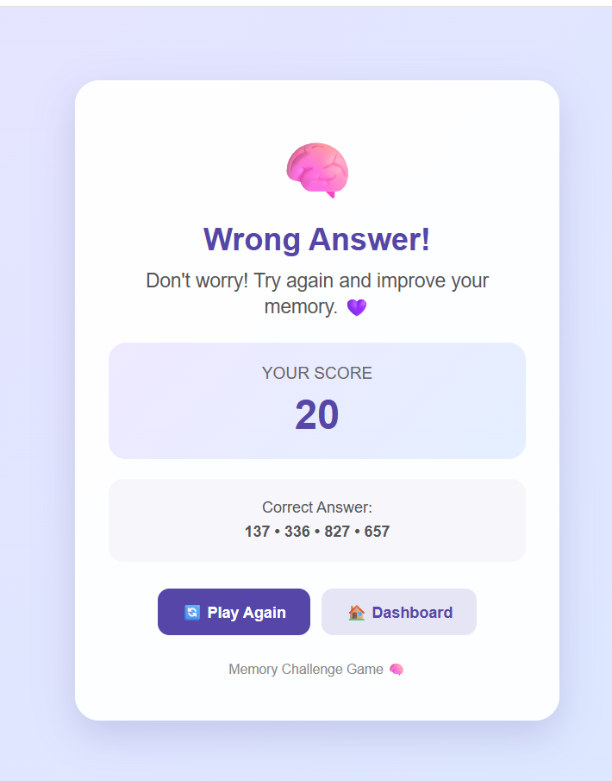

6.6 This Activity Displays the Words Game

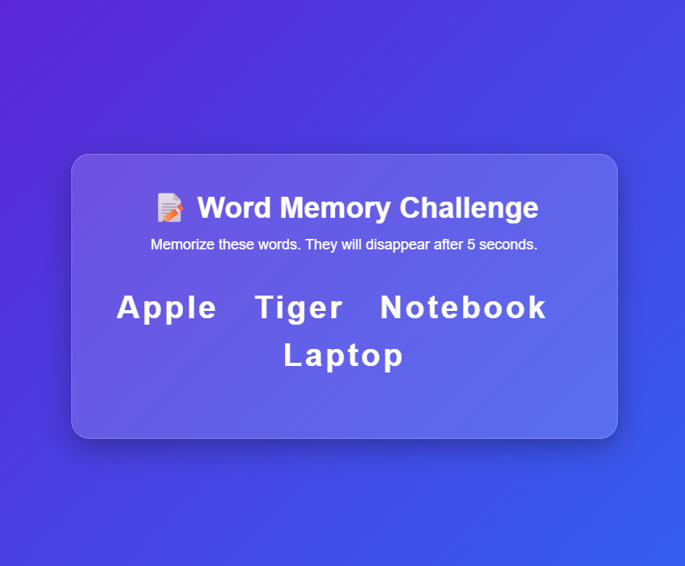

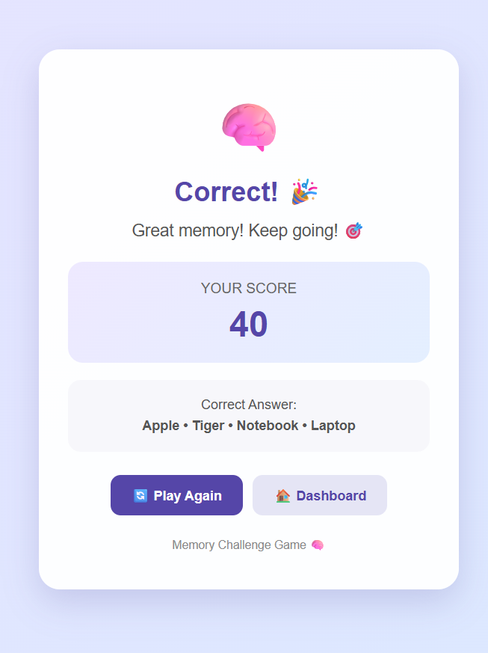
6.7 Displays the score of Words Game

- LIMITATIONS AND FUTURE ENHANCEMENT

- Limitations :-

The game currently provides only two game types:

Digits and Words.
• The Digit Game contains only four levels.
• The Words Game currently displays a fixed set of words from the available word list.
• The game requires a user to register and login before playing.
• The score system is currently limited to the rules defined for the Digit and Word games.

- Future Enhancement:-

- More levels can be added to make the game more challenging.

- More game types such as pictures, patterns, and symbols can be added.
- A leaderboard can be added to compare scores between users.
- Difficulty l evels can be increased based on the user's performance.
- More words and digit combinations can be added to the game.
- User performance and previous scores can be displayed on the dashboard.

- CONCLUSION

The Memory Challenge Game has been successfully developed using Python, Flask, and MySQL. It includes Registration, Login, Dashboard, Digit Game, and Word Game. The game helps users improve their memory and concentration through different levels and score-based challenges.

- REFERENCES AND BIBLIOGRAPHY

The following references were used for the development and documentation of the Memory Challenge Game.

- Websites:-

  - Python Documentation
• Flask Documentation
• MySQL Documentation
• HTML and CSS Documentation

Technologies Used:
• Python
• Flask
• MySQL
• HTML
• CSS
• JavaScript

